Landscape & Irrigation System Monthly Service Report

Client | Facilities Management Khidmah | Facilities Management | Location
Location | Wave Tower, Reem Island Abu Dhabi | JOB CODE | 82A12809
Service Provided | Landscape & Irrigation Maintenance | Month | August 2026

ANNUAL PROACTIVE PLAN MAINTENANCE
Activities | Frequency | Jan. | Feb. | Mar. | April | May | June | July | Aug. | Sep. | Oct. | Nov. | Dec.
General cleaning/Removal of debris | Weekly | ● | ● | ● | ● | ● | ● | ● | ● | ● | ● | ● | ●
Checking of water availability | Weekly | ● | ● | ● | ● | ● | ● | ● | ● | ● | ● | ●
Hand-watering of Pots | Weekly | ● | ● | ● | ● | ● | ● | ● | ● | ● | ● | ●
Pruning Shrubs & Hedges | Monthly | ● | ● | ● | ● | ● | ● | ● | ● | ● | ● | ● | ●
Pruning Groundcovers | Monthly | ● | ● | ● | ● | ● | ● | ● | ● | ● | ● | ● | ●
Weeding | Monthly | ● | ● | ● | ● | ● | ● | ● | ● | ● | ● | ● | ●
Soil Cultivation | Monthly | ● | ● | ● | ● | ● | ● | ● | ● | ● | ● | ● | ●
Trees (Crown Thinning, cleaning) | Bi-Monthly | ● |  | ● |  | ● |  | ● |  | ● |  | ●
Fertilization | Quarterly |  | ● |  |  | ● |  |  | ● |  |  | ●
Palm Trees Services (Coconut Trees) | Quarterly |  |  |  | ● |  |  |  | ● |  |  |  | ●
Irrigation Maintenance | Quarterly | ● |  |  | ● |  |  | ● |  |  | ●
Irrigation Controller timing change | Quarterly |  | ● |  | ● |  |  |  | ● |  |  | ●
Agriculture Pest Control | Half Yearly + As required |  |  |  | ● |  |  |  |  | ●
Trees (Crown Reduction) Hard-Pruning | Annual |  |  |  |  |  |  |  |  |  |  |  | ●

OPERATIONS PERFORMANCE
PPM TASKS Carried-out during the Month:
Activity | Frequency | Complete (✓) | Pending (✗) | Remarks
General cleaning/Removal of debris | Weekly | ✓
Checking of water availability | Weekly | ✓
Hand-watering of Pots | Weekly | ✓
Pruning Shrubs & Hedges | Monthly | ✓
Pruning Groundcovers | Monthly | ✓
Weeding | Monthly | ✓
Soil Cultivation | Monthly | ✓
Fertilization | Quarterly | ✓
Palm Trees Services (Coconut Trees) | Quarterly | ✓
Irrigation Controller timing change | Quarterly | ✓

EXTRA OR PENDING TASKS Carried-out during the Month:
S/N | Description
01 | N/A

REACTIVE MAINTENANCE TASKS Carried-out during the Month:
S/N | Description
01 | N/A

OPERATIONAL CONSTRAINS
S/N | Incident Description | Status
01 | N/A | Open

OPERATIONS CONTACT DETAILS
Role | Name | Phone | Email
Irrigation Engineer | Sijo Jose | 052 403 7552 | sijo@italianplanters.com
Operations Coordinator | Ebin Shiji | 052 848 0151 | operations@italianplanters.com

OSH TRAINING
- Emergency rescue plan
- COSHH & spillage procedure
- Fire Safety
- Common falling object

PHOTOGRAPHS
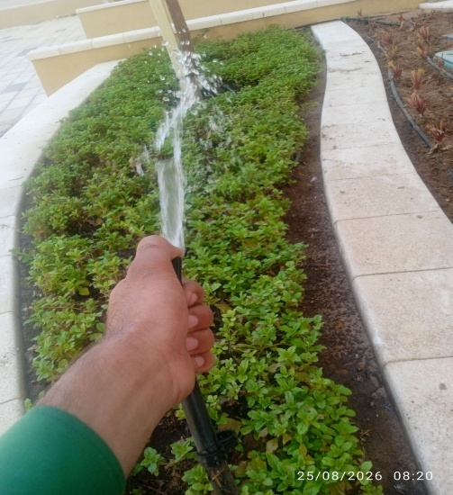 | 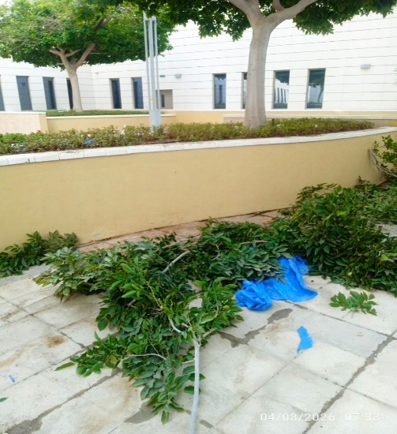 | 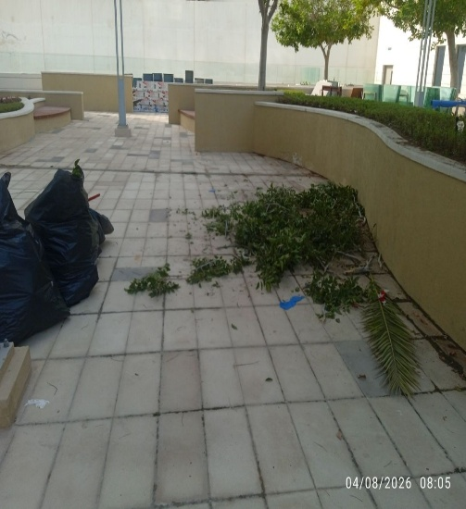
Manual Watering | tree Pruning | Cleaning After Pruning
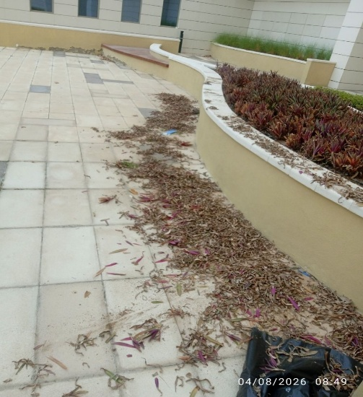 | 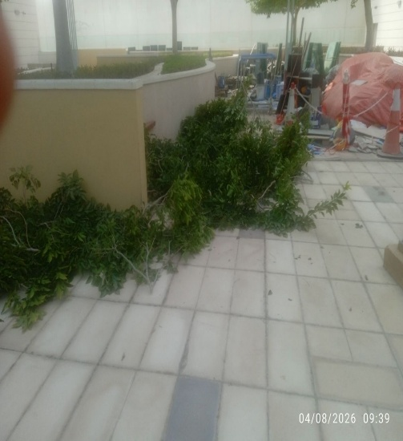 | 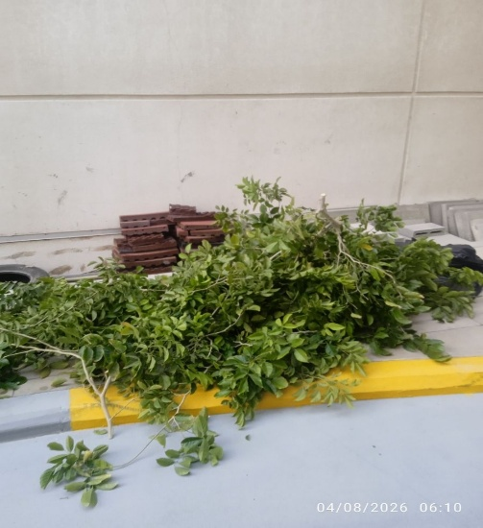
Cleaning and Removal of Fallen Dry Leaves | Cleaning After Pruning | Cleaning After Pruning
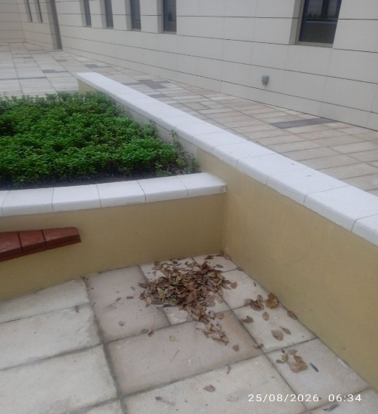 | 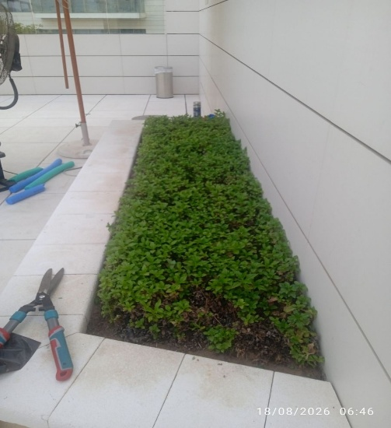 | 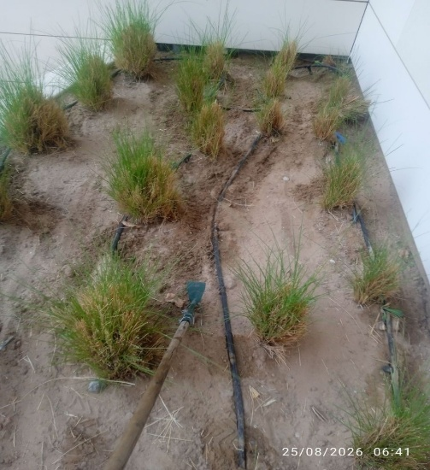
Cleaning and Removal of Fallen Dry Leaves | Trimming Activity | Soil Cultivation

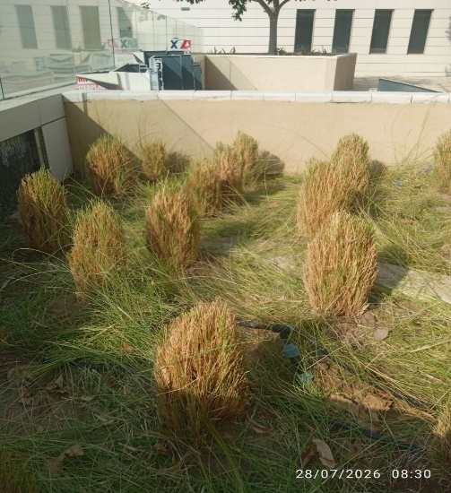 | 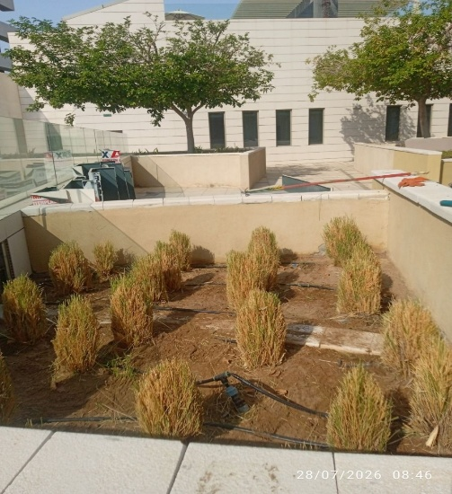 | 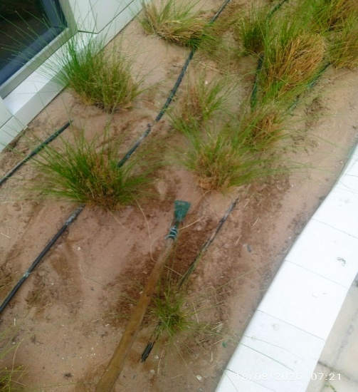
before | After trimming and shaping | Soil Cultivation
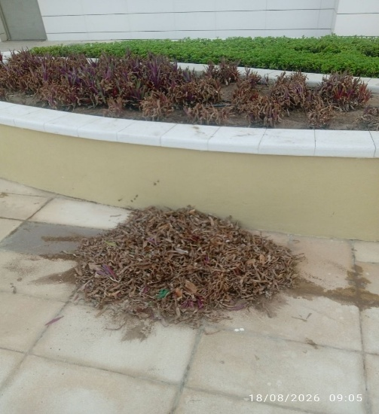 | 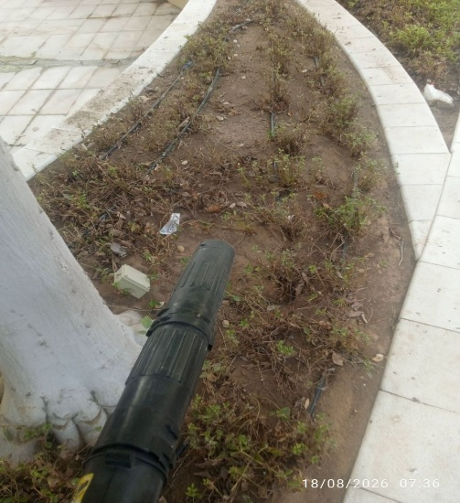 | 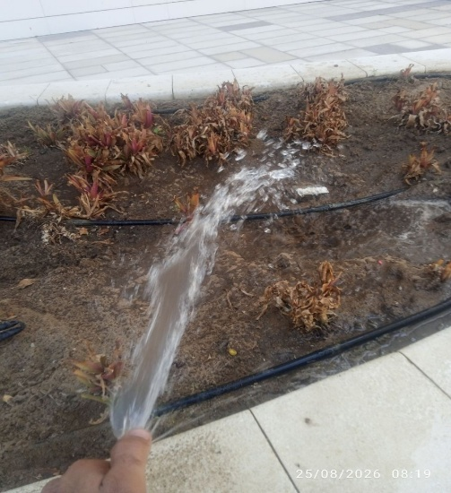
Cleaning and Removal of Fallen Dry Leaves | Cleaning and Removal of Fallen Dry Leaves | Manual Watering
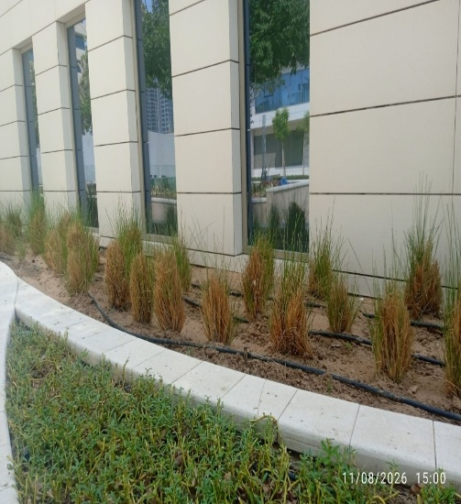 | 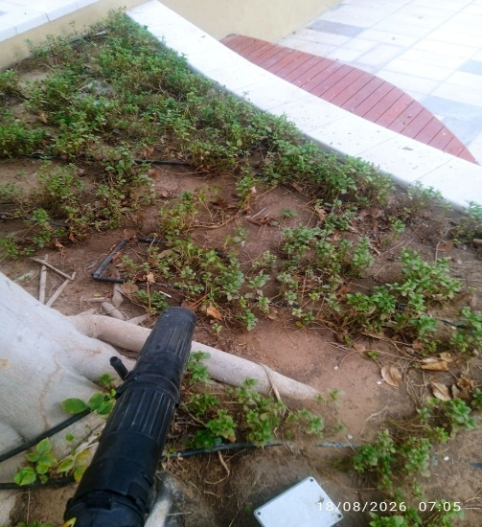 | 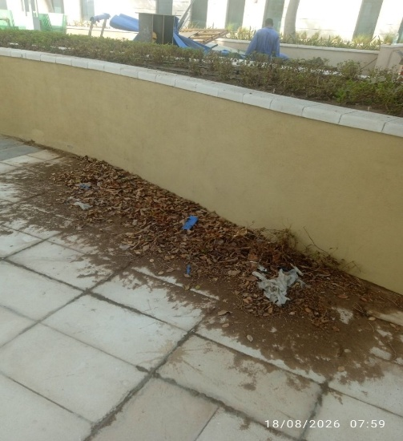
after Soil Cultivation | Cleaning and Removal of Fallen Dry Leaves | Cleaning and Removal of Fallen Dry Leaves and Waste

ITALIAN PLANTERS |  | Khidmah Sole Proprietorship LLC
Approved By: | Basem Adel | Approved By:
Designation: | Project Manager | Designation:
Signature: |  | Signature:
Date: | 07-09-2026 | Date:

